Simulation Results

3 phase Diode Rectifier + Buck Converter was chosen as a DC motor driver .Simulation was made to know our motor driver.Results are given.

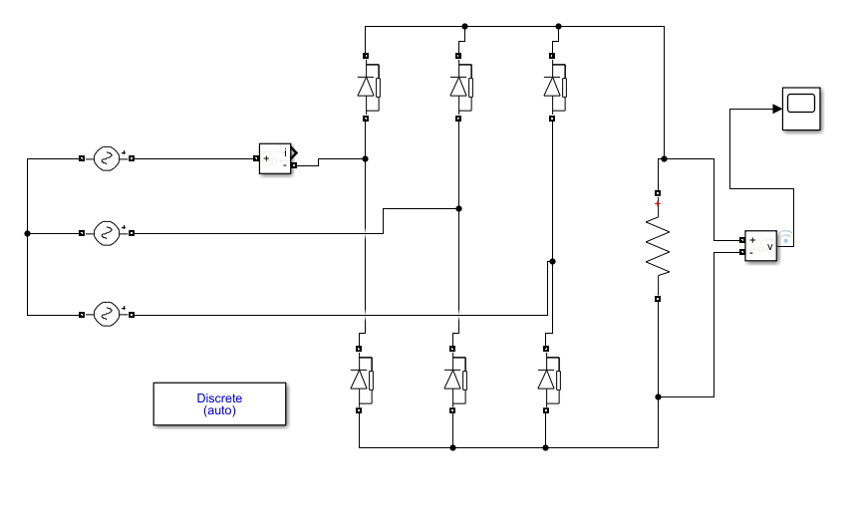
Figure x. 3 Phase diode rectifier without capacitor.

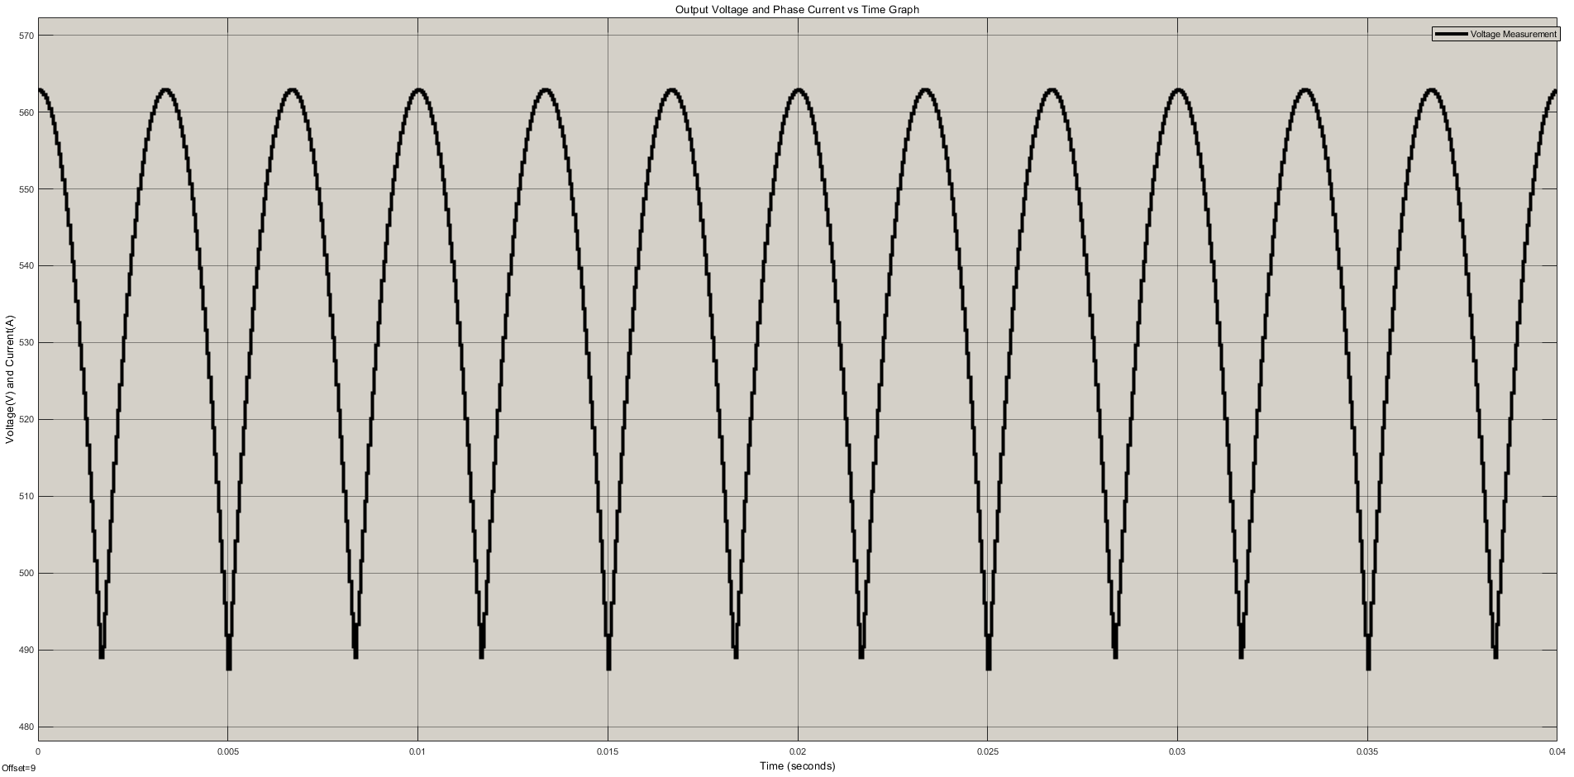
Figure x . Output voltage waveform of 3 phase rectifier without capacitor

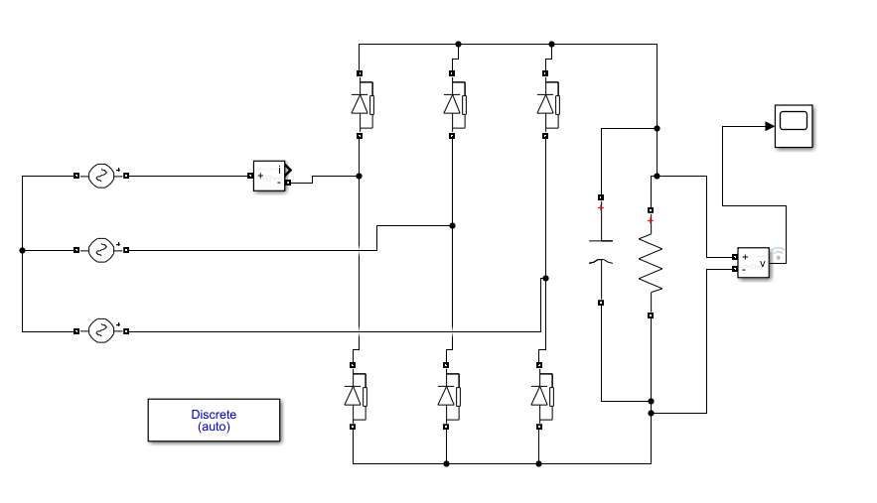
Figure x. 3 Phase diode rectifier

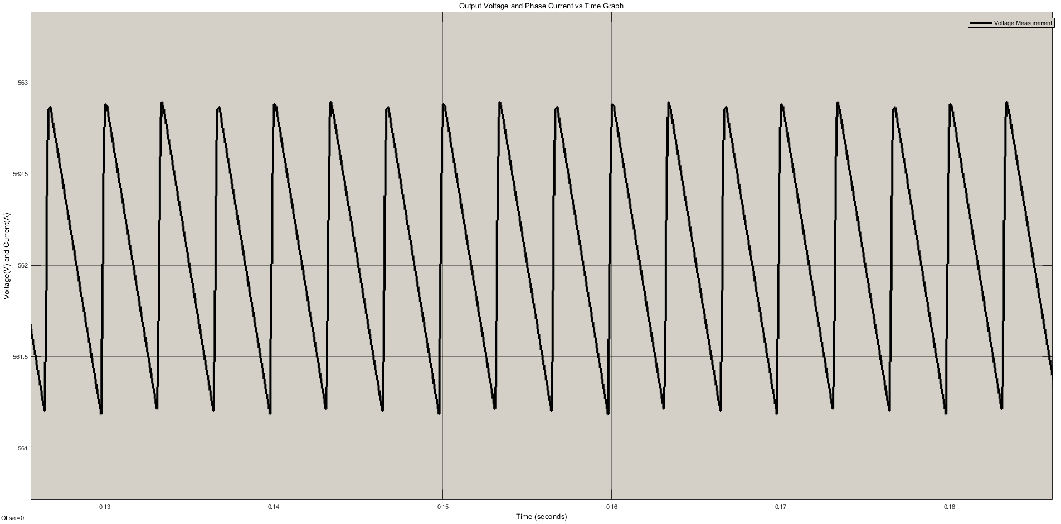
Figure x . Output waveform by using 10 mF capacitor

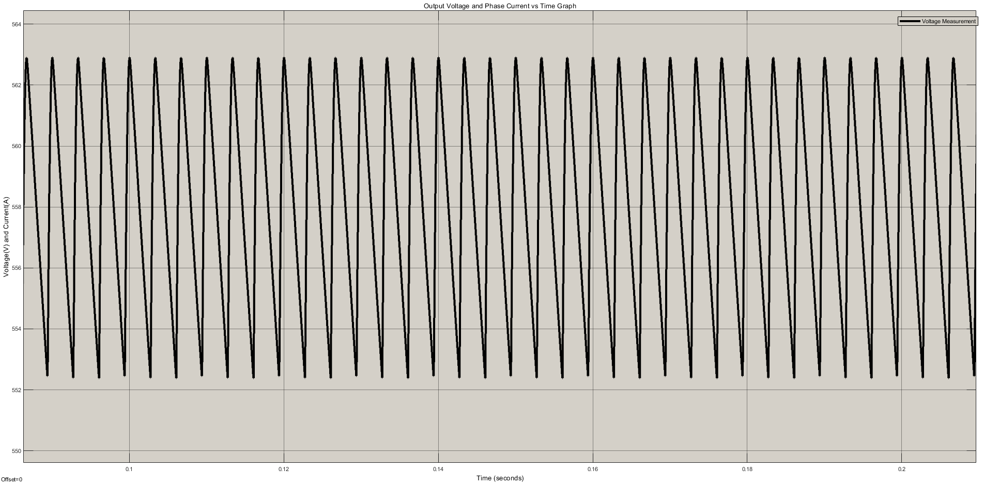
Figure x . Output waveform by using 1.4 mF capacitor

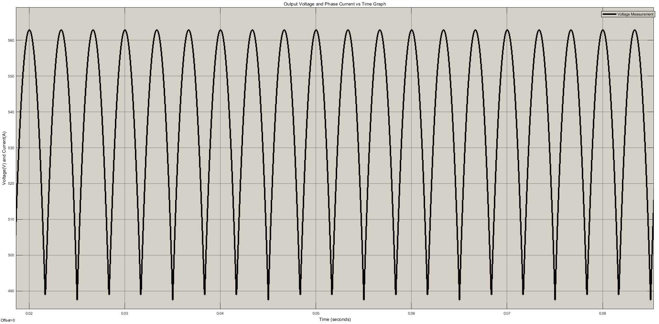
Figure x . Output waveform by using 0.01 mF capacitor

10mF Capacitor was chosen because the peak to peak voltage differences is very low.It is closer to DC voltage.We need to step down our output voltage because we need maximum 180 Voltage DC to drive our DC motor.Buck converter system was simulated to step down our output voltage.We need a duty cycle generator. Thanks to duty cycle generator we can control our DC output voltage. Simulation of buck converter is given.

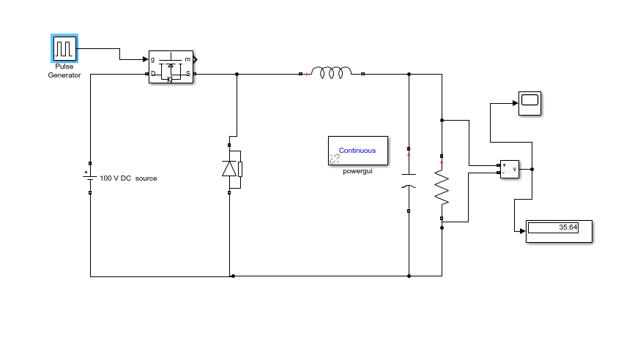
Figure x. Schematic of Buck Converter

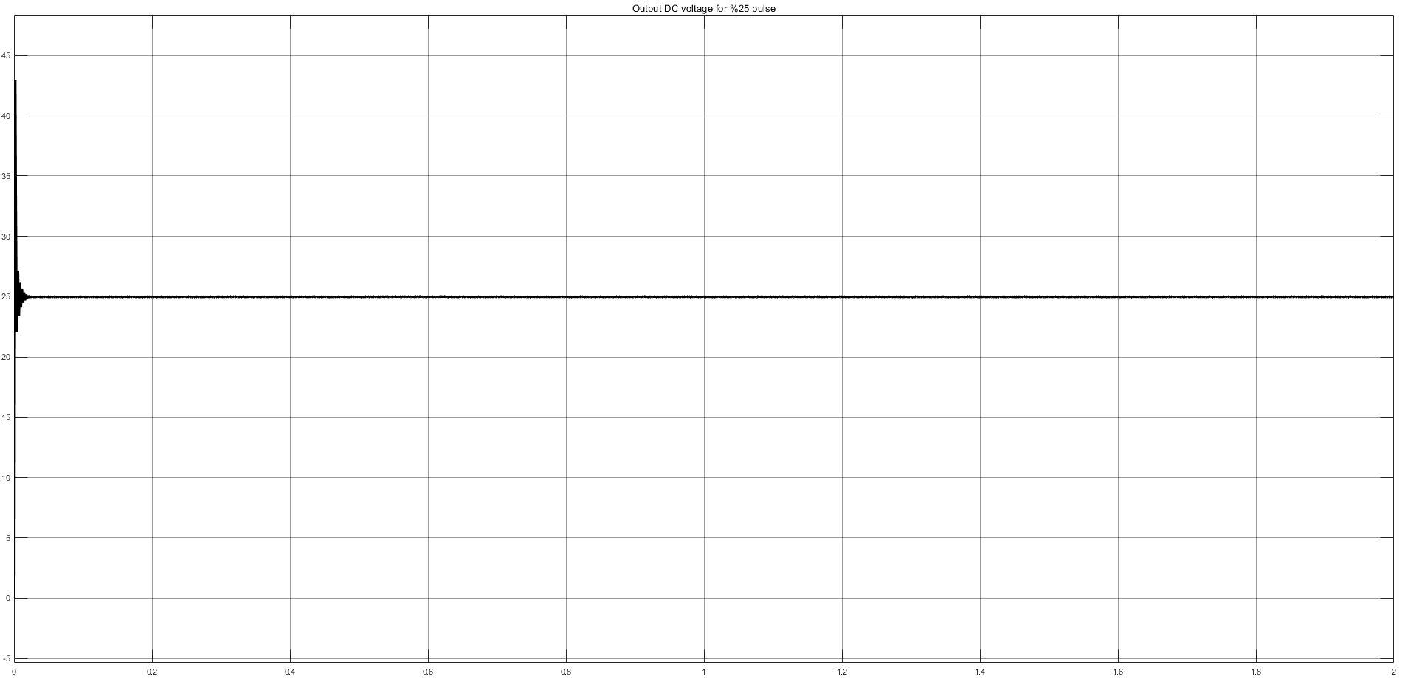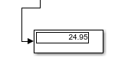
Figure x. Output voltage form of %25 Buck Converter.(Display screen)

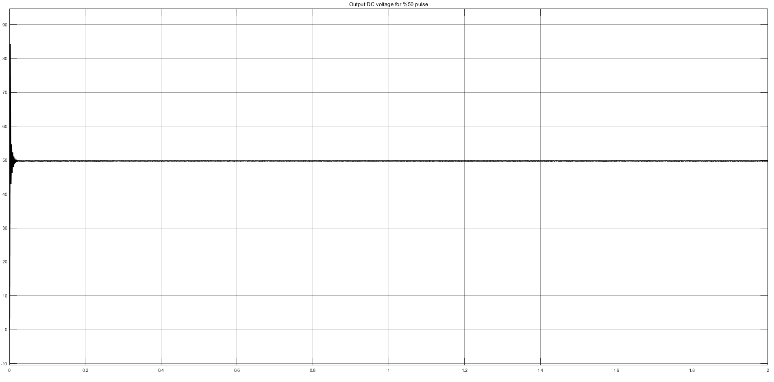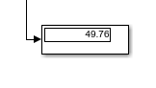
Figure x. Output voltage form of %50 Buck Converter.(Display screen)

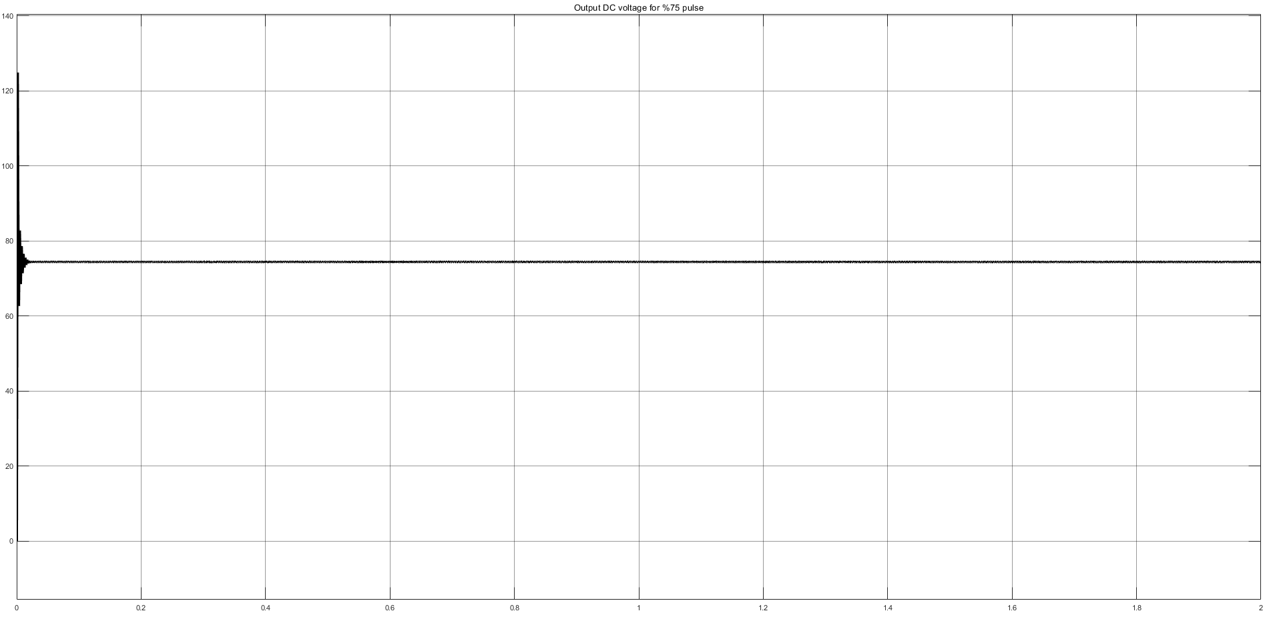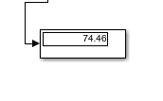
Figure x. Output voltage form of %75 Buck Converter.(Display screen)

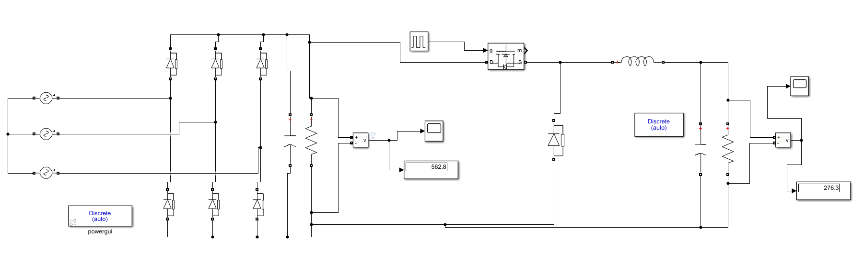
Figure x. Overall design with %50 Buck Converter
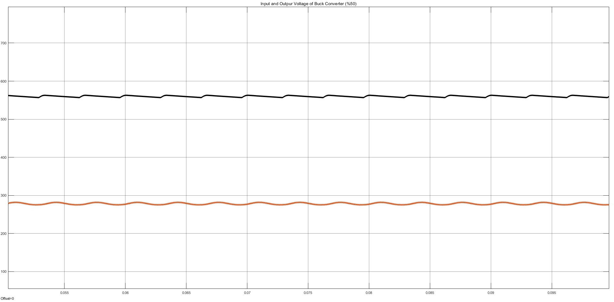
Figure x. Input and Output voltage waveform of Buck Converter (%50) (Overall system)

